**Preheater Cyclone Jamming**

What is the function of /Use of Preheater in cement plant?

* Preheaters are used industrial dry kiln cement production plants to heat the raw mix and drive off carbon dioxide and water before it is fed into the kiln.

What is the function of cyclone in cement plant?

* separators. significant numbers for handling high volumetric flow rates of dust-laden gases. from gas streams. Cyclones are often used as precleaners to remove more than 80% of the particles greater than 20µm in diameter.

The cyclone preheater is consist of six parts, including the upper feeding system, preheater, roller pusher, hydraulic system, lower feeding room, and etc.

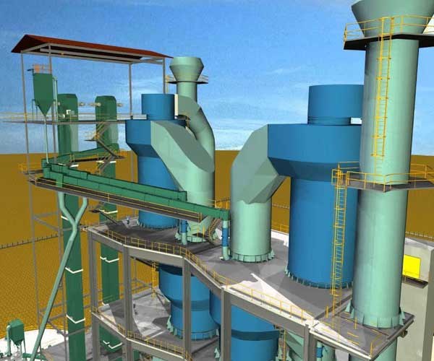

**Mechanics of a Cyclone**

The cyclone operation is characterized by two key parameters**, collection efficiency and pressure drop,** both controlled by the mechanics of gas flow.

The **collection efficiency, η,**may be characterized empirically:

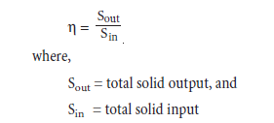

**Pressure drop across a cyclone is affected by a number of factors:**

• Expansion of the gas stream upon entering the cyclone  
• Kinetic energy losses in the spiral trajectory within the cyclone  
• Friction losses  
• Kinetic energy recovery as pressure energy at the outlet

Numerous theoretical and empirical equations have been proposed for calculating the cyclone pressure drop (Casal and Martinez-Benet, 1983). It is generally agreed that it is proportionate to the ratio between inlet velocity and cyclone diameter as given below:

https://sp-ao.shortpixel.ai/client/to_auto,q_lossless,ret_img,w_124,h_55/https:/www.cementequipment.org/wp-content/uploads/2021/06/img_60d492d9d5802.png

where,

v= inlet velocity  
D = cyclone diameter

It can be seen that **increasing the gas velocity and/or reducing the cyclone diameter would improve the separation efficiency**, but also **increase the pressure drop**. the pressure drop is also affected by the **separation efficiency,** since the latter determines the dust load and, subse-quently, the kinetic energy of the gas stream.

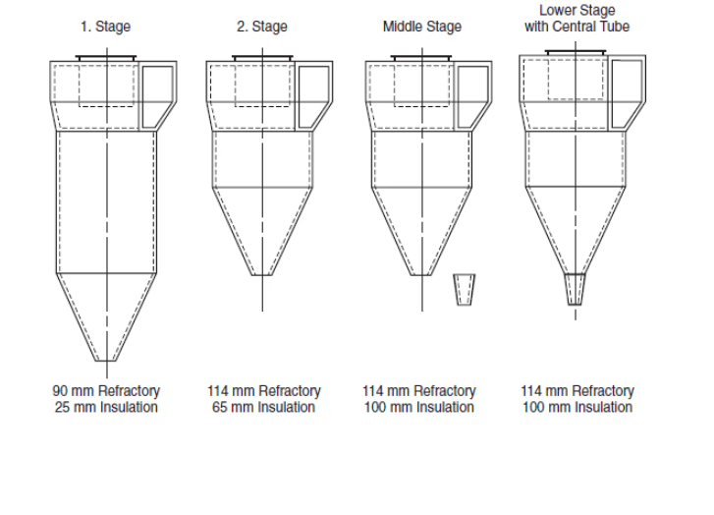

Various cyclone configuration

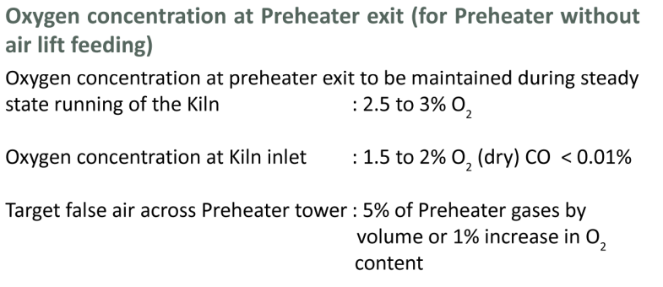

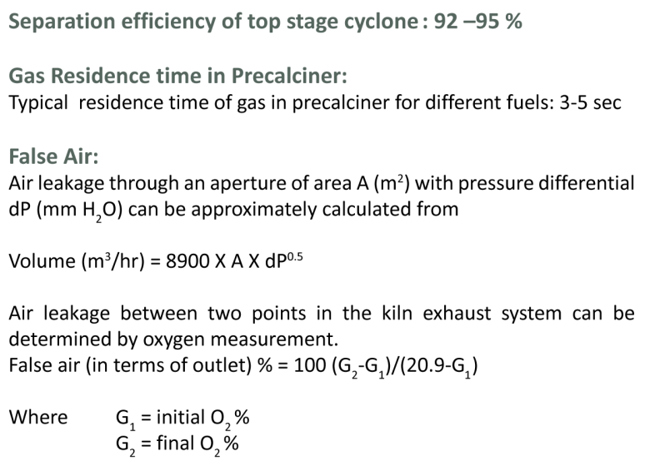

**Causes/Problem of cyclone Jamming are**:

* Kiln inlet & upper part of preheater temp is high
* Mismatching of kiln inlet & precalciner outlet temp
* Increase recirculation of fine particles at bottom stage cyclone
* In sufficient of suction due to low RPM of PH Fan
* Incomplete consumption of coal
* Increased recirculation of fine particles at bottom stage of cyclone
* Internal circulation of volatile, So3, Cl, Alkalis in cyclone
* Insufficient of suction in cyclone due to low RPM of preheater PH Fan.

**MECHANICAL ASPECTS**

* 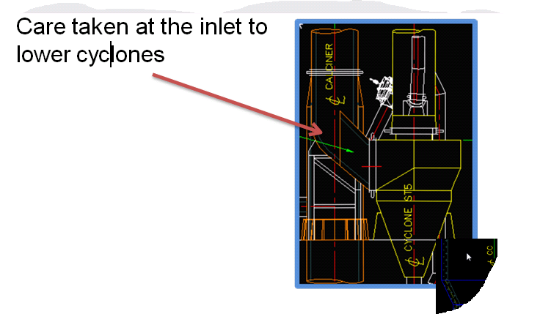
* 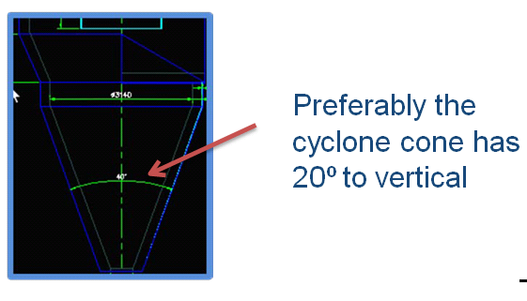
* 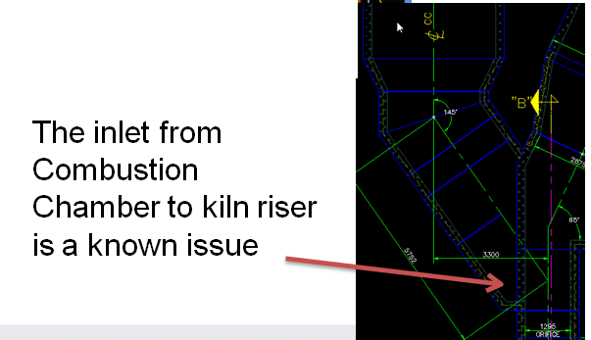

**Chemistry point of view:**

Cl(Clorine) + Alkalis(K20,Na2O) => kcl, NaCl

Na2SO4

**Factors for recirculating behavior of volatile**

NaCl Melting point is 801 ˚C, KCl Melting point is 776 ˚C, Na₂So₄ Melting point is 884 ˚C, K₂So₄ Melting point is 1074 ˚C, CaSo₄ Melting point is 1450 ˚C, K₂Co₃ Melting point is 897 ˚C, Na₂Co₃ Melting point is 854 ˚C

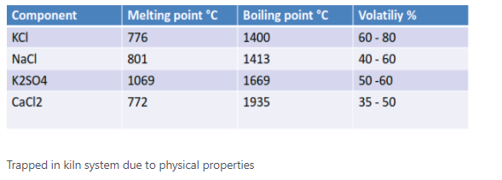

**Solution**

What are the remedial measure to avoid cyclone jamming?

1. Maintain So₃ level in Hot meal 6%, Maintain Chloride level in Hot meal 3.5%
2. Monitor & Balance Alkalis Sulphur Ratio between 0.8 to 1.2

Alkaline high, not balanced by sulphar(Free alkalin enter into kiln they chages the formation) vice versa

Solution STEPS

* Ongoing analysis of hot meal (LOI, SO3, Cl, Na2O, K2O, CaO)
* Pyro-section mass and heat balance
* Plot ongoing points on Cl-SO3 graph
* Sample the build-up material (XRF)
* Analyse Inputs-Outputs for responsible circulating element

**Cyclone blockage Indirect Detecting Method**

**The cyclone blockage Indirect Detecting Method includes following Steps:**

**1) in automatic control system, transfer following three data: the mine-supplying quantity of**

* **bowl mill,**
* **cyclone feed ore concentration,**
* **cyclone feed pump is added discharge,**

**2) according to the size of the normal mine-supplying quantity of bowl mill, set the critical value Q of mine-supplying quantity, the critical value Q of this mine-supplying quantity gets the 55--65% of normal mine-supplying quantity,**

3) **according to the size of the normal feed ore concentration of cyclone**, **set the critical value C of feed ore concentration, the critical value C of this feed ore concentration gets the 65--75% of normal feed ore concentration,**

4) **normally add the size of the water yield according to the cyclone feed pump, set the critical value F that adds the water yield, this critical value F that adds the water yield gets the 190--210% of normal discharge,**

**When actual mine-supplying quantity greater than the Q value, actual cyclone feed ore concentration is lower than the C value, actual revolving to the pump pond added the water yield greater than the F value, three conditions possess simultaneously, and duration when above in 10 seconds, are judged to be cyclone blockage, system sends warning, when above condition has one to eliminate, and alarm release.**

**Solution/system**

**Process monitoring at the preheater -** [**MKAS**](https://www.sick.com/br/en/products-by-tasks/measuring/concentration/continuous-emission-monitoring-systems-cems/mkas/c/g475855)

The composition of flue gases at the outlet of the preheater provides information about the burning process and indicates an imminent risk of explosion for the downstream electrostatic precipitator.

To acquire this information, changes in the concentration of the gas components CO, NO, O2, and, if applicable, SO2, and CH4 are measured at the preheater**. The MKAS multi-component analyzer system with the GMS800 gas analyzer** is suited to this measuring task, involving high dust loading, high gas temperatures and space limitations.

* [Continuous emission monitoring systems (CEMS) MKAS](https://www.sick.com/br/en/products-by-tasks/measuring/concentration/continuous-emission-monitoring-systems-cems/mkas/c/g475855)

**Buildup measurement in cyclones**

* In clinker production, cyclones are used to preheat the raw meal. Before the raw meal enters the rotary kiln it is preheated to +900 °C in the cyclone. Constant monitoring of the buildup thickness on the walls ensures a continuous process. **SOLITRAC 31 Radiometric sensor for continuous level measurement is suited for for level measurement**

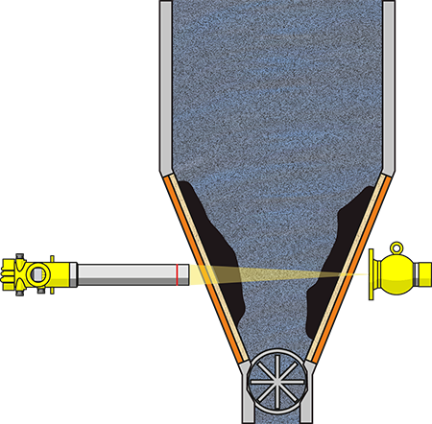

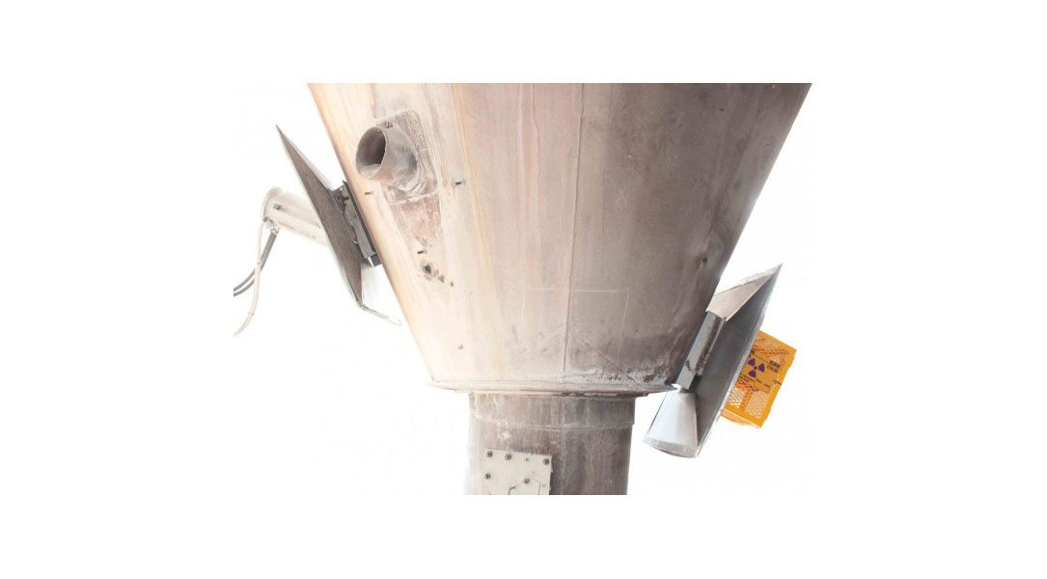

<https://www.vega.com/en-us/industries/cement-industry/cyclone>

**ABC 7**

* The ABC 7 control console is the core of the cyclone blockage detector. It collects the measuring signals of the individual monitoring zones of different cyclones. When a material blockage occurs in one of the connected cyclones, the operators are informed immediately, and the conveyor fans in the corresponding areas shut down via voltage-free relay outputs.

<http://www.siebert.com.br/wp-content/uploads/2014/10/Monitoramento-de-Ciclones-ABC-7.pdf>

**Blockage Detection System**

* The Cyclone Blockage Detection System allows one to monitor the mass of material in the Cyclone (normally flowing down the Cyclone walls).
* Under normal operational conditions the material in the cyclone will be within certain defined limits. By monitoring the output from the Cyclone Blockage Detection System it has been proven that it is possible to avoid the blockage in the first instance!
* The system provides both a continuous analogue (4-20 mA) output and a programmable alarm (relay) output. Field Bus output is also available.
* **Should the early warning provided from the Cyclone Blockage Detection System be ignored, resulting in a choke in the Cyclone under-flow, the (traditional) underflow choke detector will indicate an alarm as before.**

<https://process-auto.com/product/gamma-cyclone-blockage-detection/>

**Use The preheater bypass system**

[**https://www.cementequipment.org/home/cyclone-preheaters/**](https://www.cementequipment.org/home/cyclone-preheaters/)

**Multistage Preheaters**

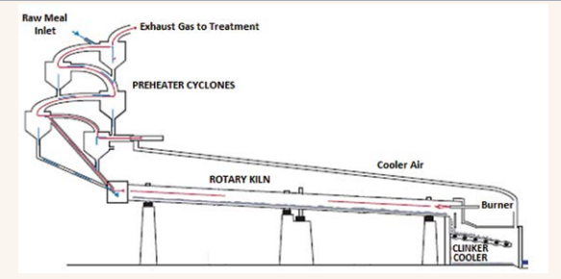

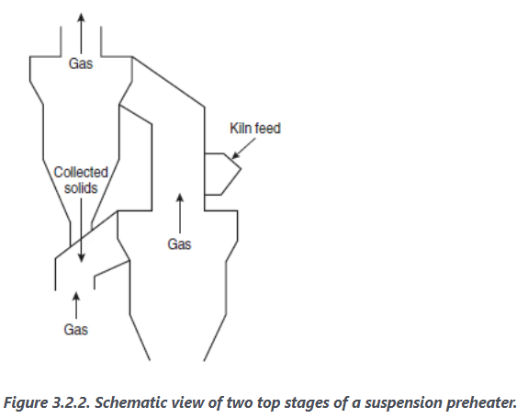

The decision whether to use one, two, or three strings depends on the intended production rate.

In the current practice, one-string preheaters are usually proposed for a production rate of up to 5000-6000 ton/day. A two-string preheater is recom-mended for production rates higher than 6000 ton/day. For production exceeding 12,000 ton/day, use of three strings of cyclones for preheating and calcination may be considered appropriate.

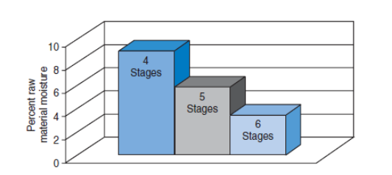

As per above image on 6th stage percent raw material moisture is low compare to 4th stage. So there is less chance for jamming.

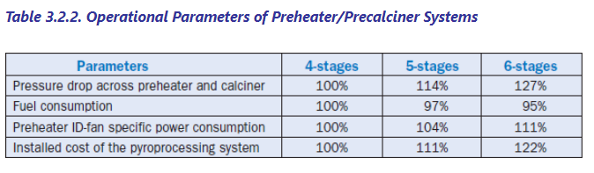

<https://www.cementequipment.org/home/everything-you-need-to-know-about-preheaters-and-precalciners/>

Rotary kiln is a kind of large mechanical equipment with complex structure. Once it breaks down during operation, it will cost a large amount of both time and money to repair it.

Therefore, we must pay attention to the daily maintenance of the rotary kiln, operate the device in strict accordance with the production requirements, and carry out regular inspections on it.